Review questions

**Q1. Describe the three-schema architecture.**

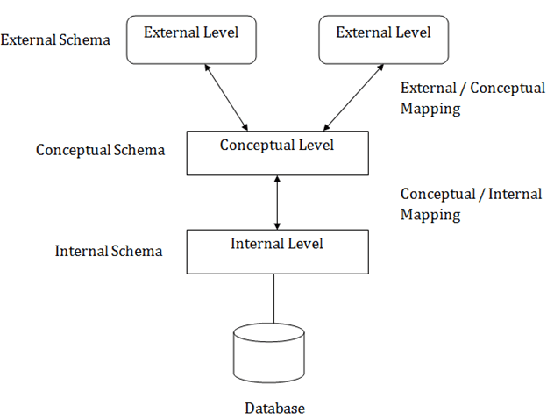

*- Internal Level*

The internal level has an internal schema which describes the physical storage structure of the database.

*- Conceptual Level*

The conceptual schema describes the design of a database at the conceptual level. Conceptual level is also known as logical level.

*- External Level*

At the external level, a database contains several schemas that sometimes called as subschema. The subschema is used to describe the different view of the database.

**2. Define the following terms and give an example for each term: an attribute, the domain of an attribute, a relation schema, a relation, n-tuple, degree of a relation, a relationship, a relation instance (state), a relational database schema, a relational database state, integrity constraints.**

*- An attribute*: An attribute is an characteristic of all the tuples of database.

Ex: ID, name, salary.

*- The domain of an attribute*: The set of values that each attribute can be.

Ex: Student(gentle) = |gentle| = [Male, Female]

*- A relation schema*: A relation schema is a set of attributes.

Ex: student(Stu_ID, name, day_of_birth)

*- A relation*: A relation is a set of attribute with its tuples

Ex: 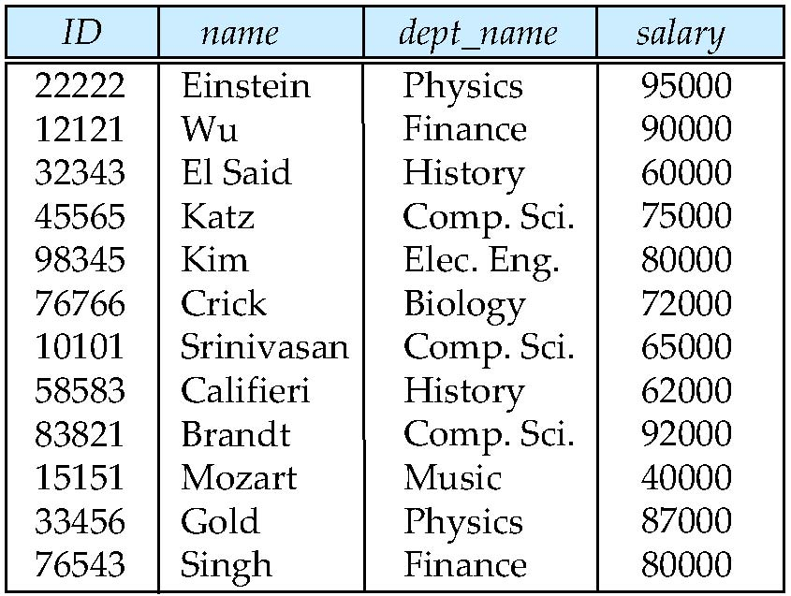

*- n-tuple*: (a1, a2,…,an).

*- Degree of a relation:* It is the number of attributes of its relation schema.

*- A relationship*: A relationship among relations represents an association among relations.

Ex: A works-on relationship between a student and a department: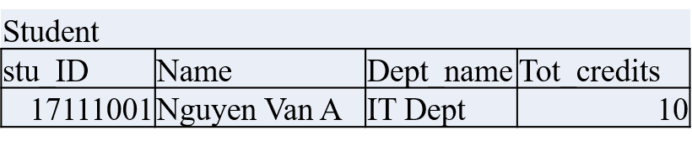

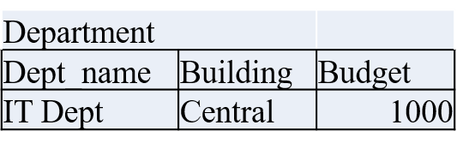Why are tuples in a relation not ordered?

*- A relation instance (state):* The current values of a relation.

- *A relational database schema:* A relational schema for a database is an outline of how data is organized. It can be a graphic illustration or another kind of chart used by programmers to understand how each table is laid out, including the columns and the types of data they hold and how tables connect. It can also be written in SQL code.

Ex: 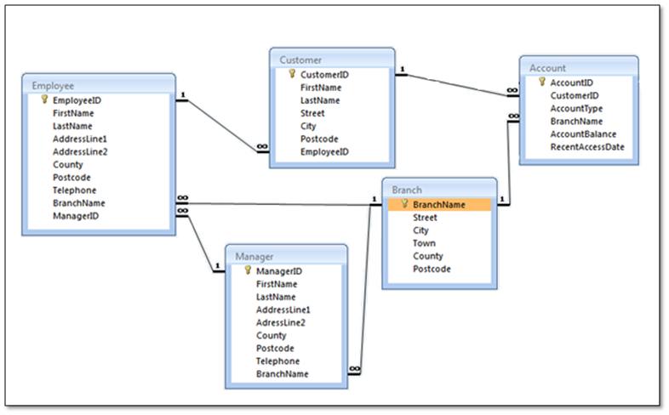

*- A relational database state:* Set of relation states

*- Integrity constraints:* the set of rules that the data in the database must satisfy to ensure that database is always correct.

Ex. The integrity constraints of the Stu_ID attribute are unique and not null

**3. Why are duplicate tuples not allowed in a relation?**

Duplicate tuples are not allowed in a relation because they created redundancy of data base which makes the data processing like querying, inserting, deleting, updating etc slow the speed of data base.

**4. What is the difference between a key and a superkey?**

*- Key*: An attribute or combination of attributes that uniquely identify an entity/record in a relational table.

- *A superkey* is a combination of attributes that can be uniquely used to identify a database record. A table might have many superkeys. Candidate keys are a special subset of superkeys that do not have any extraneous information in them.

**5. Discuss the entity integrity and referential integrity constraints. Why is each considered important?**

Entity integrity and referential integrity are two forms of data integrity that are particularly important in relational databases. ... Without guarantees of these two types of integrity, data would get dropped or duplicated.